# Chicago / Evanston House Hunting Dashboard

**Tableau is a great tool for creating interactive dashboards.** Your goal is to create a Tableau dashboard that will help you with your home search in Chicago and Evanston.

## Data

The *redfin_listings_chicago.csv* and *redfin_listings_evanston.csv* files contain all the new home listings on [Redfin](https://www.redfin.com/) from the past week. Import both into Tableau and combine the two files.

**Checkpoint:** Double check that there are 343 Chicago homes and 11 Evanston homes.

## Scatter Plot

Create a scatter plot of the square feet vs the price of each home. Make the points for Chicago homes and Evanston homes different colors. Insert a trend line for the homes in each city.

**Checkpoint:** The R2 for the trend line should be 0.5 for Chicago homes and 0.8 for Evanston homes. How would you interpret the trend line equations?

## Map

Create a map of the Chicago / Evanston area. Color each zip code based on the average home price in that zip code. Display the number of homes in each zip code.

**Checkpoint:** Double check that the zip code with the most listings (20) is 60614 and the average home price there is $1.04M.

## Histogram

Create a histogram of bedrooms. Color the tallest bar of the histogram a different color. The result should look like this:

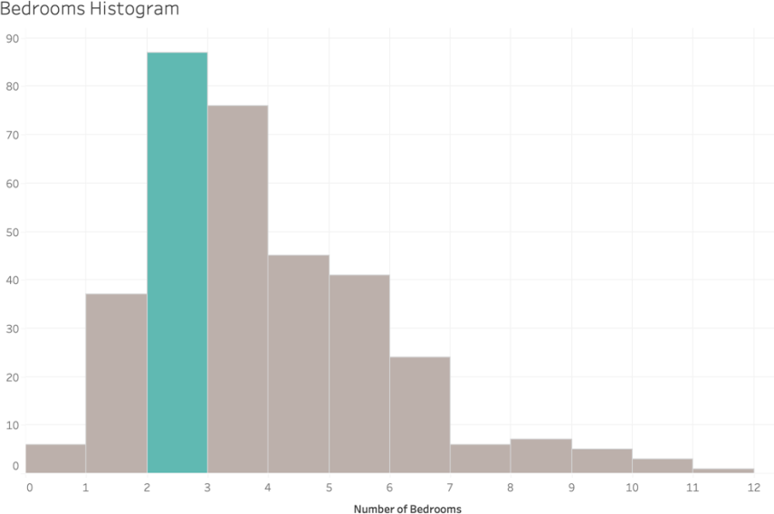

**Checkpoint:** Confirm that you have 12 bars total. Confirm that when you filter on only *Multi- Family* homes, the tallest bar is still highlighted.

## Table

Create a table in a worksheet that contains details about each home. It should look like this:

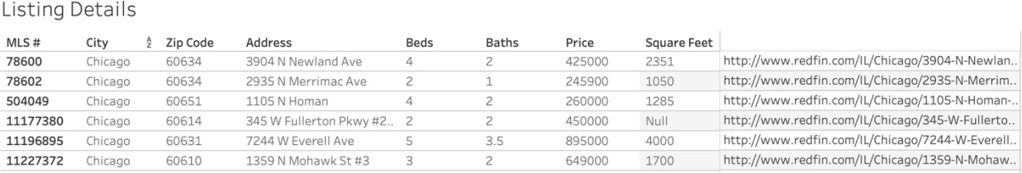

**Checkpoint:** Make sure the column names match the screenshot above (you’ll have to rename a few columns) and that the default column with ‘Abc’ values is removed.

## Dashboard

Create a dashboard that contains the four worksheets you’ve created above. It should look

something like this:

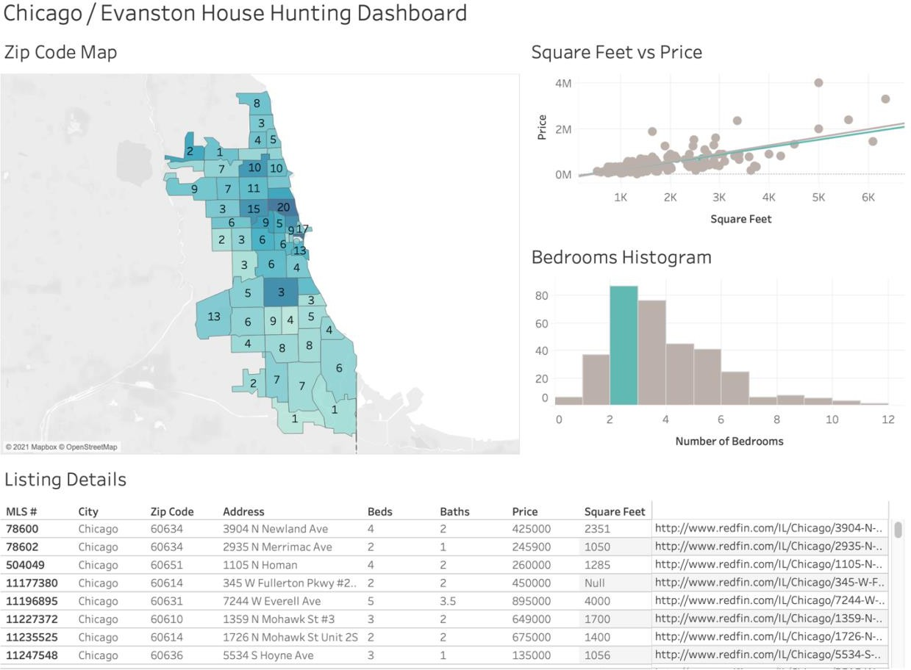

**Extension:** Play around with the size of the dashboard / positioning of the worksheets / colors / text / labels / tooltips / filters / etc. until it looks polished.

## Actions

Create two actions to make the dashboard interactive:

* + - When you click on a zip code on the map, all of the other worksheets should update so that only data for that particular zip code is shown
    - When you hover over a point in the scatter plot, the listing details section should only display that particular home

**Checkpoint:** When you click away from a zip code, all of the original data should appear again.

## Design

Is there anything else you can think to either add or change to make this a better user experience? Remember that your goal is to create a dashboard to help you with your home search.

# Candy Data Exploration

**Tableau is a great tool for exploring new data sets.** You are tasked with ordering candy for the annual MLDS Halloween party. You want to make sure you purchase a good variety of candies for everyone to enjoy. Use Tableau to come up with a data-driven approach to present to Diego so that he will approve your candy choices.

## Data

The *candy_data.csv* file includes data about 80+ types of candy. You can find more details about the data set on [Kaggle.](https://www.kaggle.com/fivethirtyeight/fivethirtyeight-candy-power-ranking-dataset)

**Optional:** There is a special character in the *Competitorname* column that is out of place. Find it and figure out how to fix the issue.

## Exploration

Use Tableau to help you better understand the candy data to make your decision. Come up with at least one visualization and your suggested candy choices.